UNITED STATES
SECURITIES AND EXCHANGE COMMISSION
Washington, D.C. 20549
Form 8-K

CURRENT REPORT
Pursuant to Section 13 or 15(d) of the
Securities Exchange Act of 1934
Date of Report (Date of earliest event reported): August 10, 2026
Surgery Partners, Inc.
(Exact Name of Registrant as Specified in Charter)
Delaware |  |  | 001-37576 |  |  | 47-3620923
(State or Other Jurisdiction  of Incorporation) |  |  | (Commission  File Number) |  |  | (IRS Employer  Identification No.)
340 Seven Springs Way, Suite 600
Brentwood, Tennessee 37027
(Address of Principal Executive Offices) (Zip Code)
(615) 234-5900
(Registrant’s Telephone Number, Including Area Code)

Check the appropriate box below if the Form 8-K filing is intended to simultaneously satisfy the filing obligation of the registrant under any of the following provisions:
☐ Written communications pursuant to Rule 425 under the Securities Act (17 CFR 230.425)
☐ Soliciting material pursuant to Rule 14a-12 under the Exchange Act (17 CFR 240.14a-12)
☐ Pre-commencement communications pursuant to Rule 14d-2(b) under the Exchange Act (17 CFR 240.14d-2(b))
☐ Pre-commencement communications pursuant to Rule 13e-4(c) under the Exchange Act (17 CFR 240.13e-4(c))
Securities registered pursuant to Section 12(b) of the Act:
Title of each class |  |  |  |  |  | Trading Symbol(s) |  |  |  |  |  | Name of each exchange on which registered
Common Stock, par value $0.01 per share |  |  |  |  |  | SGRY |  |  |  |  |  | The Nasdaq Global Select Market
Indicate by check mark whether the registrant is an emerging growth company as defined in as defined in Rule 405 of the Securities Act of 1933 (§230.405 of this chapter) or Rule 12b-2 of the Securities Exchange Act of 1934 (§240.12b-2 of this chapter).
Emerging growth company ☐
If an emerging growth company, indicate by check mark if the registrant has elected not to use the extended transition period for complying with any new or revised financial accounting standards provided pursuant to Section 13(a) of the Exchange Act. ☐

Item 2.02 Results of Operations and Financial Condition.
On August 10, 2026, Surgery Partners, Inc. (the "Company") issued a press release announcing results for the three and six months ended June 30, 2026. See the press release attached as Exhibit 99.1.
In accordance with General Instruction B.2 of Form 8-K, the information in this Current Report on Form 8-K, including Exhibit 99.1, shall not be deemed "filed" for the purpose of Section 18 of the Securities Exchange Act of 1934 or otherwise subject to the liabilities of that section, nor shall it be deemed incorporated by reference in any filing under the Securities Act of 1933.
The Company makes reference to non-GAAP financial measures in the attached press release and a reconciliation of such non-GAAP financial measures to the most directly comparable GAAP financial measures is provided therein.

Item 7.01 Regulation FD Disclosure.
The Company will hold a conference call on August 10, 2026 at 8:30 a.m. (Eastern Time) to discuss the Company’s financial results for the second quarter and six months ended June 30, 2026. In addition to the press release, an earnings presentation will be made available on the Investor Relations section of the Company's website at www.surgerypartners.com. A copy of the earnings presentation is furnished as Exhibit 99.2 to this Current Report on Form 8-K and incorporated herein by reference.
The information furnished pursuant to this Item 7.01 to this Current Report on Form 8-K, including the exhibit, is being “furnished” and, as such, shall not be deemed to be “filed” for the purposes of Section 18 of the Exchange Act, or otherwise subject to the liabilities of that section, nor shall it be incorporated by reference into any filing under the Securities Act or the Exchange Act, except as shall be expressly set forth by specific reference in such filing.

Item 9.01. Financial Statements and Exhibits.
(d) Exhibits:
99.1 |  |  |  |  |  | Press release dated August 10, 2026
99.2 |  |  |  |  |  | Q2 2026 Earnings Presentation
104 |  |  |  |  |  | Cover Page Interactive Data File (embedded within the Inline XBRL document)

SIGNATURES
Pursuant to the requirements of the Securities Exchange Act of 1934, the registrant has duly caused this report to be signed on its behalf by the undersigned hereunto duly authorized.

 |  |  |  |  |  | SURGERY PARTNERS, INC.
Date: |  |  | August 10, 2026 |  |  | By: |  |  | /s/ David T. Doherty
 |  |  |  |  |  |  |  |  | David T. Doherty
 |  |  |  |  |  |  |  |  | Executive Vice President and Chief Financial Officer

Exhibit 99.1


SURGERY PARTNERS, INC. ANNOUNCES SECOND QUARTER 2026 RESULTS
REAFFIRMS FULL YEAR 2026 GUIDANCE

BRENTWOOD, Tenn., August 10, 2026 (GLOBE NEWSWIRE) - Surgery Partners, Inc. (NASDAQ:SGRY) (“Surgery Partners” or the “Company”), a leading short-stay surgical facility owner and operator, today announced results for the second quarter ended June 30, 2026.
Second Quarter 2026 Financial Highlights
(All comparisons are year-over-year unless otherwise noted)
•Revenue increased 2.7% for the second quarter
◦Same-facility revenues increased 5.0% for the second quarter
◦Same-facility cases increased 0.3% for the second quarter
•Net loss attributable to Surgery Partners, Inc. was $15.0 million for the second quarter
◦Adjusted EBITDA was $125.2 million for the second quarter
2026 Guidance
•Full year 2026 revenue guidance reaffirmed to be in the range of $3.35 billion to $3.45 billion and Adjusted EBITDA of at least $530 million, excluding recently disclosed pending divestiture
Eric Evans, Chief Executive Officer, stated, “We are pleased with our progress this quarter, which reflects disciplined execution against our key strategic priorities to support a return to growth and reinforces our conviction in our short stay surgical platform. The announcement of the pending Idaho Falls transaction was a key achievement and represents an important step forward in our portfolio optimization strategy, as we take decisive actions to improve our financial profile and sharpen our strategic focus. Looking ahead, we will capitalize on the structural tailwinds underpinning long-term ASC market growth, enhance operational efficiency, and thoughtfully deploy capital to deliver long-term value for our shareholders.”
Dave Doherty, Chief Financial Officer, commented, “Our financial results in the second quarter demonstrate the momentum of our ongoing initiatives to improve performance, and we are reiterating full-year guidance as a result. The Idaho Falls transaction, which remains subject to closing conditions including physician members and governing board approvals, will further strengthen our financial position, through improved cash conversion and deleveraging. Going forward, we are committed to disciplined capital allocation to support the continued growth of our business.”

Second Quarter 2026 Results
Revenues for the second quarter of 2026 increased 2.7% to $848.9 million compared to $826.2 million for the second quarter of 2025. Same-facility revenues for the second quarter of 2026 increased 5.0% as compared to the same period in prior year, with a 4.8% increase in revenue per case and a 0.3% increase in same-facility cases. For the second quarter of 2026, the Company’s Adjusted EBITDA was $125.2 million, compared to $129.0 million for the same period in 2025.
Year-to-Date 2026 Results
Revenues year-to-date 2026 increased 3.6% to $1,659.8 million compared to $1,602.2 million for the 2025 period. Same-facility revenues for year-to-date 2026 increased 4.9% as compared to the prior year, with a 4.0% increase in revenue per case and a 0.8% increase in same-facility cases. For year-to-date 2026, the Company’s Adjusted EBITDA was $227.5 million, compared to $232.9 million for the same period last year.

Liquidity
Surgery Partners had cash and cash equivalents of $216.7 million and $617.8 million of borrowing capacity under its revolving credit facility as of June 30, 2026. Cash flows from operating activities were $59.3 million for the second quarter of
1
2026, compared to $81.3 million for the same period in 2025. Year-to-date, operating cash flows were $71.0 million compared to $87.3 million in the prior year period.
The Company’s ratio of total net debt to EBITDA, as calculated under the Company’s credit agreement, was approximately 4.4x at the end of the second quarter of 2026.

2026 Outlook
The Company reaffirmed its outlook for 2026 revenues to be in the range of $3.35 billion to $3.45 billion and Adjusted EBITDA of at least $530 million, excluding the impact of the recently disclosed pending divestiture of our facilities in Idaho Falls, Idaho.

Conference Call Information
Surgery Partners will hold a conference call today, August 10, 2026 at 8:30 a.m. (Eastern Time). The conference call can be accessed live over the phone by dialing 1-877-451-6152, or for international callers, 1-201-389-0879. A replay will be available three hours after the call and can be accessed by dialing 1-844-512-2921, or for international callers, 1-412-317-6671. The passcode for the live call and the replay is 13761354. The replay will be available until August 24, 2026.
Interested investors and other parties may also listen to a simultaneous webcast of the conference call by logging onto the Investor Relations section of the Company's website at www.surgerypartners.com. The replay will also be available on this same website for a limited time following the call.
To learn more about Surgery Partners, please visit the Company's website at www.surgerypartners.com. Surgery Partners uses its website as a channel of distribution for material Company information. Financial and other material information regarding Surgery Partners is routinely posted on the Company's website and is readily accessible.

About Surgery Partners
Headquartered in Brentwood, Tennessee, Surgery Partners is a leading healthcare services company with a differentiated outpatient delivery model focused on providing high quality, cost effective solutions for surgical and related ancillary care in support of both patients and physicians. Founded in 2004, Surgery Partners is one of the largest and fastest growing surgical services businesses in the country, with more than 200 locations in 30 states, including ambulatory surgery centers, surgical hospitals, multi-specialty physician practices and urgent care facilities. For additional information, visit www.surgerypartners.com.

Forward-Looking Statements
This press release contains forward-looking statements, including those regarding growth, our anticipated operating results for future periods and other similar statements. These statements can be identified by the use of words such as "believes," "anticipates," "expects," "intends," "plans," "continues," "estimates," "predicts," "projects," "forecasts," "may," "could," and similar expressions. All forward-looking statements are based on current expectations and beliefs as of the date of this release and are subject to risks, uncertainties and other factors that may cause actual results to differ materially from the expectations discussed in, or implied by, the forward-looking statements. Many of these factors are beyond our ability to control or predict including, without limitation, the risk that the potential sale transaction of our ownership interests in Mountain View Hospital and Idaho Falls Community Hospital to Intermountain Health may not be completed in a timely manner or at all, including the risk that required physician, regulatory and other approvals and consents are not obtained, are delayed, or are obtained subject to conditions that are not anticipated; the failure to satisfy other closing conditions to the transaction; the possibility that the anticipated benefits of the sale to us are not realized as expected, the potential adverse effect of the announcement or pendency of the transaction on the market price of, or trading in, our securities and on our business relationships, operating results, and business generally, including the ability to retain key personnel; risks related to diverting management's attention from our ongoing business operations; the amount of costs, fees, expenses, and charges related to the sale transaction; potential litigation relating to the transaction that could be instituted against us or our affiliates, officers, or directors, and the effects of any outcomes related thereto; reductions in payments from government health care programs and private insurance payors, such as health maintenance organizations, preferred provider organizations, and other managed care organizations and employers; our ability to contract with private insurance payors; changes in our payor mix or surgical case mix; failure to maintain or develop relationships with physicians on beneficial or favorable terms, or at all; the impact of payor controls designed to reduce the number of surgical procedures; our efforts to integrate operations of acquired or developed businesses and surgical facilities, attract new physician partners, or acquire additional surgical facilities; supply chain issues, including shortages or quality control issues with surgery-related products, equipment and medical supplies; competition for physicians,
2
nurses, strategic relationships, acquisitions and managed care contracts; our ability to attract and retain qualified health care professionals; our ability to enforce non-compete restrictions against our physicians; our ability to manage material liabilities whether known or unknown incurred as a result of acquiring or operating surgical facilities; the impact of future legislation and other health care regulatory reform actions, and the effect of that legislation and other regulatory actions on our business; our ability to comply with current health care laws and regulations; the outcome of legal and regulatory proceedings that have been or may be brought against us; the impact of cybersecurity attacks or intrusions, changes in the regulatory, economic and other conditions of the states where our surgical facilities are located; our indebtedness; the social and economic impact of a pandemic, epidemic or outbreak of a contagious disease on our business; and the risks and uncertainties identified and discussed from time to time in the Company’s reports filed with the Securities and Exchange Commission (the "SEC"), including in Item 1A under the heading "Risk Factors" in the Company’s Annual Report on Form 10-K for the year ended December 31, 2025 and other reports filed with the SEC. Except as required by law, the Company undertakes no obligation to revise or update publicly any forward-looking statements to reflect events or circumstances after the date of this report, or to reflect the occurrence of unanticipated events or circumstances.

Use of Non-GAAP Financial Measures
In addition to the results prepared in accordance with generally accepted accounting principles in the United States ("GAAP") provided throughout this press release, Surgery Partners has presented the following non-GAAP financial measures: Adjusted net income (loss) attributable to common stockholders, Adjusted net income (loss) per share attributable to common stockholders, Adjusted EBITDA, and Adjusted EBITDA related to unconsolidated affiliates, which exclude various items detailed in the "Reconciliation of Non-GAAP Financial Measures" below.
These non-GAAP financial measures are not intended to replace financial performance measures determined in accordance with GAAP. Rather, they are presented as supplemental measures of the Company's performance that management believes may enhance the evaluation of the Company's ongoing operating results. These non-GAAP financial measures are not presented in accordance with GAAP, and the Company’s computation of these non-GAAP financial measures may vary from similar measures used by other companies. These measures have limitations as an analytical tool and should not be considered in isolation or as a substitute or alternative to revenue, net income or loss, operating income or loss, cash flows from operating activities, total indebtedness or any other measures of operating performance, liquidity or indebtedness derived in accordance with GAAP.

3
SURGERY PARTNERS, INC.
Selected Consolidated Financial Data
(Dollars in millions, except per share amounts, shares in thousands)
(Unaudited)
 |  |  |  |  |  | Three Months Ended June 30, |  |  |  |  |  |  |  |  |  |  |  | Six Months Ended June 30,
 |  |  |  |  |  | 2026 |  |  |  |  |  | 2025 |  |  |  |  |  | 2026 |  |  |  |  |  | 2025
Revenues |  |  |  |  |  | $ | 848.9 |  |  |  |  | $ | 826.2 |  |  |  |  | $ | 1,659.8 |  |  |  |  | $ | 1,602.2
Operating expenses:
Salaries and benefits |  |  |  |  |  | 253.1 |  |  |  |  |  | 235.2 |  |  |  |  |  | 500.5 |  |  |  |  |  | 473.8
Supplies |  |  |  |  |  | 226.8 |  |  |  |  |  | 215.0 |  |  |  |  |  | 447.0 |  |  |  |  |  | 430.8
Professional and medical fees |  |  |  |  |  | 102.8 |  |  |  |  |  | 102.1 |  |  |  |  |  | 204.1 |  |  |  |  |  | 197.4
Lease expense |  |  |  |  |  | 24.2 |  |  |  |  |  | 22.9 |  |  |  |  |  | 47.2 |  |  |  |  |  | 43.7
Other operating expenses |  |  |  |  |  | 51.8 |  |  |  |  |  | 55.4 |  |  |  |  |  | 110.6 |  |  |  |  |  | 99.0
Cost of revenues |  |  |  |  |  | 658.7 |  |  |  |  |  | 630.6 |  |  |  |  |  | 1,309.4 |  |  |  |  |  | 1,244.7
General and administrative expenses |  |  |  |  |  | 36.3 |  |  |  |  |  | 36.1 |  |  |  |  |  | 75.6 |  |  |  |  |  | 72.1
Depreciation and amortization |  |  |  |  |  | 39.3 |  |  |  |  |  | 40.3 |  |  |  |  |  | 77.8 |  |  |  |  |  | 76.6
Transaction and integration costs |  |  |  |  |  | 18.4 |  |  |  |  |  | 18.1 |  |  |  |  |  | 34.0 |  |  |  |  |  | 42.8
Net (gain) loss on disposals, consolidations and deconsolidations |  |  |  |  |  | 2.4 |  |  |  |  |  | (3.0) |  |  |  |  |  | 6.7 |  |  |  |  |  | 3.4
Equity in earnings of unconsolidated affiliates |  |  |  |  |  | (6.4) |  |  |  |  |  | (5.5) |  |  |  |  |  | (10.5) |  |  |  |  |  | (11.1)
Litigation settlements |  |  |  |  |  | — |  |  |  |  |  | — |  |  |  |  |  | 2.5 |  |  |  |  |  | 2.2
Other income, net |  |  |  |  |  | (1.9) |  |  |  |  |  | (2.1) |  |  |  |  |  | (3.6) |  |  |  |  |  | (2.1)
 |  |  |  |  |  | 746.8 |  |  |  |  |  | 714.5 |  |  |  |  |  | 1,491.9 |  |  |  |  |  | 1,428.6
Operating income |  |  |  |  |  | 102.1 |  |  |  |  |  | 111.7 |  |  |  |  |  | 167.9 |  |  |  |  |  | 173.6
Interest expense, net |  |  |  |  |  | (69.8) |  |  |  |  |  | (67.9) |  |  |  |  |  | (138.9) |  |  |  |  |  | (130.1)
Income (loss) before income taxes |  |  |  |  |  | 32.3 |  |  |  |  |  | 43.8 |  |  |  |  |  | 29.0 |  |  |  |  |  | 43.5
Income tax (expense) benefit |  |  |  |  |  | (2.6) |  |  |  |  |  | 1.1 |  |  |  |  |  | (1.4) |  |  |  |  |  | 1.1
Net income (loss) |  |  |  |  |  | 29.7 |  |  |  |  |  | 44.9 |  |  |  |  |  | 27.6 |  |  |  |  |  | 44.6
Less: Net income attributable to non-controlling interests |  |  |  |  |  | (44.7) |  |  |  |  |  | (47.4) |  |  |  |  |  | (78.5) |  |  |  |  |  | (84.8)
Net income (loss) attributable to Surgery Partners, Inc. |  |  |  |  |  | $ | (15.0) |  |  |  |  | $ | (2.5) |  |  |  |  | $ | (50.9) |  |  |  |  | $ | (40.2)
Net loss per share attributable to common stockholders
Basic |  |  |  |  |  | $ | (0.12) |  |  |  |  | $ | (0.02) |  |  |  |  | $ | (0.40) |  |  |  |  | $ | (0.32)
Diluted (1) |  |  |  |  |  | $ | (0.12) |  |  |  |  | $ | (0.02) |  |  |  |  | $ | (0.40) |  |  |  |  | $ | (0.32)
Weighted average common shares outstanding
Basic |  |  |  |  |  | 128,825 |  |  |  |  |  | 126,980 |  |  |  |  |  | 128,597 |  |  |  |  |  | 126,792
Diluted (1) |  |  |  |  |  | 128,825 |  |  |  |  |  | 126,980 |  |  |  |  |  | 128,597 |  |  |  |  |  | 126,792
(1)The impact of potentially dilutive securities for all periods was not considered because the effect would be anti-dilutive.

4
SURGERY PARTNERS, INC.
Selected Financial and Operating Data
(Dollars in millions, except per case and per share amounts)
(Unaudited)
 |  |  |  |  |  | June 30,  2026 |  |  |  |  |  | December 31,  2025
Balance Sheet Data (at period end):
Cash and cash equivalents |  |  |  |  |  | $ | 216.7 |  |  |  |  | $ | 239.9
Total current assets |  |  |  |  |  | 1,126.0 |  |  |  |  |  | 1,150.7
Total assets |  |  |  |  |  | 8,049.7 |  |  |  |  |  | 8,119.7
Current maturities of long-term debt |  |  |  |  |  | 102.9 |  |  |  |  |  | 99.3
Total current liabilities |  |  |  |  |  | 578.5 |  |  |  |  |  | 615.5
Long-term debt, less current maturities |  |  |  |  |  | 3,648.3 |  |  |  |  |  | 3,602.9
Total liabilities |  |  |  |  |  | 4,581.3 |  |  |  |  |  | 4,592.9
Non-controlling interests—redeemable |  |  |  |  |  | 366.7 |  |  |  |  |  | 395.5
Total Surgery Partners, Inc. stockholders' equity |  |  |  |  |  | 1,670.7 |  |  |  |  |  | 1,712.9
Non-controlling interests—non-redeemable |  |  |  |  |  | 1,431.0 |  |  |  |  |  | 1,418.4
Total stockholders' equity |  |  |  |  |  | 3,101.7 |  |  |  |  |  | 3,131.3
 |  |  |  |  |  | Three Months Ended June 30, |  |  |  |  |  |  |  |  |  |  |  | Six Months Ended June 30,
 |  |  |  |  |  | 2026 |  |  |  |  |  | 2025 |  |  |  |  |  | 2026 |  |  |  |  |  | 2025
Cash Flow Data:
Net cash provided by (used in):
Operating activities |  |  |  |  |  | $ | 59.3 |  |  |  |  | $ | 81.3 |  |  |  |  | $ | 71.0 |  |  |  |  | $ | 87.3
Investing activities |  |  |  |  |  | (19.8) |  |  |  |  |  | 2.1 |  |  |  |  |  | (33.2) |  |  |  |  |  | (74.3)
Purchases of property and equipment |  |  |  |  |  | (21.8) |  |  |  |  |  | (23.4) |  |  |  |  |  | (37.8) |  |  |  |  |  | (46.1)
Payments for acquisitions, net of cash acquired |  |  |  |  |  | 0.1 |  |  |  |  |  | (4.0) |  |  |  |  |  | (4.1) |  |  |  |  |  | (48.0)
Purchases of equity investments |  |  |  |  |  | — |  |  |  |  |  | — |  |  |  |  |  | — |  |  |  |  |  | (3.8)
Financing activities |  |  |  |  |  | (5.1) |  |  |  |  |  | (62.6) |  |  |  |  |  | (61.0) |  |  |  |  |  | (32.4)
Distributions to non-controlling interest holders |  |  |  |  |  | (45.5) |  |  |  |  |  | (54.0) |  |  |  |  |  | (103.5) |  |  |  |  |  | (116.3)
 |  |  |  |  |  | Three Months Ended June 30, |  |  |  |  |  |  |  |  |  |  |  | Six Months Ended June 30,
 |  |  |  |  |  | 2026 |  |  |  |  |  | 2025 |  |  |  |  |  | 2026 |  |  |  |  |  | 2025
Other Data:
Number of surgical facilities as of the end of period |  |  |  |  |  | 178 |  |  |  |  |  | 162 |  |  |  |  |  | 178 |  |  |  |  |  | 162
Number of consolidated surgical facilities as of the end of period |  |  |  |  |  | 120 |  |  |  |  |  | 115 |  |  |  |  |  | 120 |  |  |  |  |  | 115
Cases |  |  |  |  |  | 167,866 |  |  |  |  |  | 172,858 |  |  |  |  |  | 325,577 |  |  |  |  |  | 333,158
Revenue per case |  |  |  |  |  | $ | 5,057 |  |  |  |  | $ | 4,780 |  |  |  |  | $ | 5,098 |  |  |  |  | $ | 4,809
Adjusted EBITDA (1) |  |  |  |  |  | $ | 125.2 |  |  |  |  | $ | 129.0 |  |  |  |  | $ | 227.5 |  |  |  |  | $ | 232.9
Adjusted EBITDA margin (2) |  |  |  |  |  | 14.7 |  | % |  |  |  | 15.6 |  | % |  |  |  | 13.7 |  | % |  |  |  | 14.5 |  | %
Adjusted net income per share attributable to common stockholders - Basic (1) |  |  |  |  |  | $ | 0.10 |  |  |  |  | $ | 0.17 |  |  |  |  | $ | 0.07 |  |  |  |  | $ | 0.22
Adjusted net income per share attributable to common stockholders - Diluted (1) |  |  |  |  |  | $ | 0.10 |  |  |  |  | $ | 0.17 |  |  |  |  | $ | 0.07 |  |  |  |  | $ | 0.21
(1)A reconciliation of these non-GAAP financial measures appears below.
(2)Defined as Adjusted EBITDA as a % of Revenues.

5
SURGERY PARTNERS, INC.
Supplemental Information
(Dollars in millions, except per case amounts)
(Unaudited)
 |  |  |  |  |  | Three Months Ended June 30, |  |  |  |  |  |  |  |  |  |  |  | Six Months Ended June 30,
 |  |  |  |  |  | 2026 |  |  |  |  |  | 2025 |  |  |  |  |  | 2026 |  |  |  |  |  | 2025
Same-facility Information (1):
Cases |  |  |  |  |  | 197,078 |  |  |  |  |  | 196,552 |  |  |  |  |  | 370,774 |  |  |  |  |  | 367,759
Case growth |  |  |  |  |  | 0.3 |  | % |  |  |  | N/A |  |  |  |  |  | 0.8 |  | % |  |  |  | N/A
Revenue per case |  |  |  |  |  | $ | 4,898 |  |  |  |  | $ | 4,676 |  |  |  |  | $ | 5,029 |  |  |  |  | $ | 4,834
Revenue per case growth |  |  |  |  |  | 4.8 |  | % |  |  |  | N/A |  |  |  |  |  | 4.0 |  | % |  |  |  | N/A
Number of work days in the period |  |  |  |  |  | 64 |  |  |  |  |  | 64 |  |  |  |  |  | 127 |  |  |  |  |  | 127
Case growth (days adjusted) |  |  |  |  |  | 0.3 |  | % |  |  |  | N/A |  |  |  |  |  | 0.8 |  | % |  |  |  | N/A
Revenue growth (days adjusted) |  |  |  |  |  | 5.0 |  | % |  |  |  | N/A |  |  |  |  |  | 4.9 |  | % |  |  |  | N/A
(1)Same-facility information includes cases and revenues from our consolidated and non-consolidated surgical facilities (excluding facilities acquired in new markets or divested during the current and prior periods).

SURGERY PARTNERS, INC.
Reconciliation of Non-GAAP Financial Measures
(Dollars in millions, except per share amounts, shares in thousands)
(Unaudited)
The following table reconciles Adjusted EBITDA to income before income taxes in the reported consolidated financial information, the most directly comparable GAAP financial measure:
 |  |  |  |  |  | Three Months Ended June 30, |  |  |  |  |  |  |  |  |  |  |  | Six Months Ended June 30,
 |  |  |  |  |  | 2026 |  |  |  |  |  | 2025 |  |  |  |  |  | 2026 |  |  |  |  |  | 2025
Income (loss) before income taxes |  |  |  |  |  | $ | 32.3 |  |  |  |  | $ | 43.8 |  |  |  |  | $ | 29.0 |  |  |  |  | $ | 43.5
Net income attributable to non-controlling interests |  |  |  |  |  | (44.7) |  |  |  |  |  | (47.4) |  |  |  |  |  | (78.5) |  |  |  |  |  | (84.8)
Interest expense, net |  |  |  |  |  | 69.8 |  |  |  |  |  | 67.9 |  |  |  |  |  | 138.9 |  |  |  |  |  | 130.1
Depreciation and amortization |  |  |  |  |  | 39.3 |  |  |  |  |  | 40.3 |  |  |  |  |  | 77.8 |  |  |  |  |  | 76.6
Equity-based compensation expense |  |  |  |  |  | 3.8 |  |  |  |  |  | 6.8 |  |  |  |  |  | 9.6 |  |  |  |  |  | 14.4
Transaction and integration costs (1) |  |  |  |  |  | 18.4 |  |  |  |  |  | 18.1 |  |  |  |  |  | 34.0 |  |  |  |  |  | 42.8
De novo start-up costs |  |  |  |  |  | 1.2 |  |  |  |  |  | 2.1 |  |  |  |  |  | 3.1 |  |  |  |  |  | 3.7
Net (gain) loss on disposals, consolidations and deconsolidations |  |  |  |  |  | 2.4 |  |  |  |  |  | (3.0) |  |  |  |  |  | 6.7 |  |  |  |  |  | 3.4
Litigation settlements and other litigation costs (2) |  |  |  |  |  | 2.7 |  |  |  |  |  | 0.4 |  |  |  |  |  | 6.9 |  |  |  |  |  | 3.2
Adjusted EBITDA (3) |  |  |  |  |  | $ | 125.2 |  |  |  |  | $ | 129.0 |  |  |  |  | $ | 227.5 |  |  |  |  | $ | 232.9
(1)For the three months ended June 30, 2026, this amount includes due diligence, transaction and integration costs related to acquisitions (both completed and in the pipeline) and divested facilities (collectively “M&A costs”) of $12.5 million and other costs, including severance, IT implementation, revenue cycle standardization of $5.9 million. For the three months ended June 30, 2025, this amount includes M&A costs of $14.1 million and other costs, including severance, IT implementation, revenue cycle standardization of $4.0 million.
For the six months ended June 30, 2026, this amount includes M&A costs of $24.3 million and other costs, including severance, IT implementation, revenue cycle standardization of $9.7 million. For the six months ended June 30, 2025, this amount includes M&A costs of $30.9 million and other costs, including severance, IT implementation, revenue cycle standardization of $11.9 million.
(2)This amount includes other litigation costs of $2.7 million and $0.4 million for the three months ended June 30, 2026 and 2025, respectively.
This amount includes a litigation settlement loss of $2.5 million and $2.2 million for the six months ended June 30, 2026 and 2025, respectively. This amount also includes other litigation costs of $4.4 million and $1.0 million for the six months ended June 30, 2026 and 2025, respectively.
(3)We use Adjusted EBITDA as a measure of financial performance. Adjusted EBITDA is a key measure used by management to assess operating performance, make business decisions and allocate resources. Non-controlling interests represent the interests of third parties, such as physicians, and in some cases, healthcare systems that own an interest in surgical facilities that we consolidate for financial reporting purposes. We believe that it is helpful to investors to present Adjusted EBITDA as defined above because it excludes the portion of net income attributable to these third-party interests and clarifies for investors our portion of Adjusted EBITDA generated by our surgical facilities and other operations. Adjusted EBITDA is not a measurement of financial performance under GAAP and should not be considered in isolation or as a substitute for net income, operating income or any other measure calculated in accordance with GAAP. The items excluded from Adjusted EBITDA are significant components in understanding and
6
evaluating our financial performance. We believe such adjustments are appropriate, as the magnitude and frequency of such items can vary significantly and are not related to the assessment of normal operating performance. Our calculation of Adjusted EBITDA may not be comparable to similarly titled measures reported by other companies.
The following table provides supplemental information for Adjusted EBITDA related to unconsolidated affiliates:
 |  |  | Three Months Ended June 30, |  |  |  |  |  |  |  |  |  |  |  | Six Months Ended June 30,
 |  |  | 2026 |  |  |  |  |  | 2025 |  |  |  |  |  | 2026 |  |  |  |  |  | 2025
Adjusted EBITDA related to unconsolidated affiliates:
Management fee revenues (1)(2) |  |  | $ | 10.5 |  |  |  |  | $ | 8.6 |  |  |  |  | $ | 20.5 |  |  |  |  | $ | 16.8
Equity in earnings of unconsolidated affiliates (2) |  |  | 6.4 |  |  |  |  |  | 5.5 |  |  |  |  |  | 10.5 |  |  |  |  |  | 11.1
Plus:
Start-up costs related to unconsolidated de novo surgical facilities (3) |  |  | 0.6 |  |  |  |  |  | 1.1 |  |  |  |  |  | 1.8 |  |  |  |  |  | 1.4
Adjusted EBITDA related to unconsolidated affiliates |  |  | $ | 17.5 |  |  |  |  | $ | 15.2 |  |  |  |  | $ | 32.8 |  |  |  |  | $ | 29.3
(1)Includes management and administrative service fees derived from the non-consolidated facilities that the Company accounts for under the equity method and management of surgical facilities in which it does not own an interest. Management fee revenues are included in Revenues on the Consolidated Statements of Operations.
(2)Included as a component of income before income taxes in the Adjusted EBITDA reconciliation table above.
(3)Included as a component of de novo start-up costs in the Adjusted EBITDA reconciliation table above.
From time to time, the Company incurs certain non-recurring gains or losses that are normally non-operational in nature and management does not consider relevant in assessing its ongoing operating performance. When significant, Surgery Partners’ management and the Company's Board of Directors typically exclude these gains or losses when evaluating the Company’s operating performance and in certain instances when evaluating performance for incentive compensation purposes. Additionally, management believes that certain investors and equity analysts exclude these or similar items when evaluating the Company’s current or future operating performance and in making informed investment decisions regarding the Company. Accordingly, the Company provides adjusted net income attributable to common stockholders and adjusted net income per share attributable to common stockholders as supplements to the comparable GAAP financial measures. Adjusted net income attributable to common stockholders and adjusted net income per share attributable to common stockholders should not be considered measures of financial performance under GAAP, and the items excluded from such measures are significant components in understanding and assessing financial performance. These measures should not be considered in isolation or as an alternative to the comparable GAAP measures as presented in the consolidated financial statements.
7
The following table reconciles net income (loss) as reflected in the consolidated statements of operations to adjusted net income attributable to common stockholders used to calculate adjusted net income per share attributable to common stockholders:
 |  |  | Three Months Ended June 30, |  |  |  |  |  |  |  |  |  |  |  | Six Months Ended June 30,
 |  |  | 2026 |  |  |  |  |  | 2025 |  |  |  |  |  | 2026 |  |  |  |  |  | 2025
Consolidated Statements of Operations Data:
Net income (loss) |  |  | $ | 29.7 |  |  |  |  | $ | 44.9 |  |  |  |  | $ | 27.6 |  |  |  |  | $ | 44.6
Plus (minus):
Net income attributable to non-controlling interests |  |  | (44.7) |  |  |  |  |  | (47.4) |  |  |  |  |  | (78.5) |  |  |  |  |  | (84.8)
Equity-based compensation expense |  |  | 3.8 |  |  |  |  |  | 6.8 |  |  |  |  |  | 9.6 |  |  |  |  |  | 14.4
Transaction and integration costs |  |  | 18.4 |  |  |  |  |  | 18.1 |  |  |  |  |  | 34.0 |  |  |  |  |  | 42.8
De novo start-up costs |  |  | 1.2 |  |  |  |  |  | 2.1 |  |  |  |  |  | 3.1 |  |  |  |  |  | 3.7
Net loss on disposals, consolidations and deconsolidations |  |  | 2.4 |  |  |  |  |  | (3.0) |  |  |  |  |  | 6.7 |  |  |  |  |  | 3.4
Litigation settlements and other litigation costs |  |  | 2.7 |  |  |  |  |  | 0.4 |  |  |  |  |  | 6.9 |  |  |  |  |  | 3.2
Adjusted net income (loss) attributable to common stockholders |  |  | $ | 13.5 |  |  |  |  | $ | 21.9 |  |  |  |  | $ | 9.4 |  |  |  |  | $ | 27.3
Adjusted net income (loss) per share attributable to common stockholders
Basic |  |  | $ | 0.10 |  |  |  |  | $ | 0.17 |  |  |  |  | $ | 0.07 |  |  |  |  | $ | 0.22
Diluted |  |  | $ | 0.10 |  |  |  |  | $ | 0.17 |  |  |  |  | $ | 0.07 |  |  |  |  | $ | 0.21
Weighted average common shares outstanding
Basic |  |  | 128,825 |  |  |  |  |  | 126,980 |  |  |  |  |  | 128,597 |  |  |  |  |  | 126,792
Diluted |  |  | 129,223 |  |  |  |  |  | 128,038 |  |  |  |  |  | 129,018 |  |  |  |  |  | 127,911
Contact
Surgery Partners Investor Relations
(615) 234-8940
IR@surgerypartners.com

8
2nd Quarter 2026 Earnings Presentation August 10, 2026

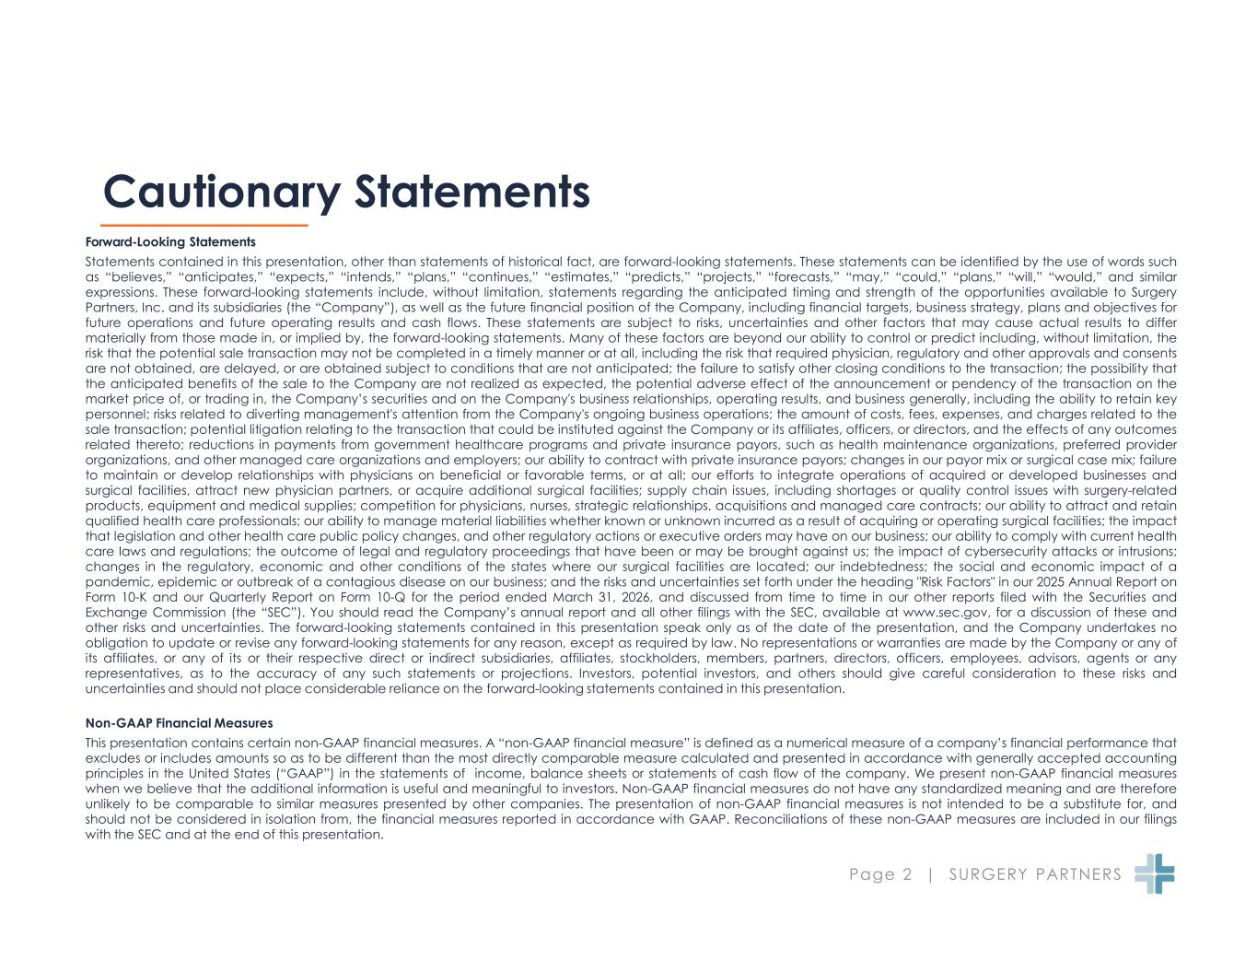
Page 2 | SURGERY PARTNERS Cautionary Statements Forward-Looking Statements Statements contained in this presentation, other than statements of historical fact, are forward-looking statements. These statements can be identified by the use of words such as “believes,” “anticipates,” “expects,” “intends,” “plans,” “continues,” “estimates,” “predicts,” “projects,” “forecasts,” “may,” “could,” “plans,” “will,” “would,” and similar expressions. These forward-looking statements include, without limitation, statements regarding the anticipated timing and strength of the opportunities available to Surgery Partners, Inc. and its subsidiaries (the “Company”), as well as the future financial position of the Company, including financial targets, business strategy, plans and objectives for future operations and future operating results and cash flows. These statements are subject to risks, uncertainties and other factors that may cause actual results to differ materially from those made in, or implied by, the forward-looking statements. Many of these factors are beyond our ability to control or predict including, without limitation, the risk that the potential sale transaction may not be completed in a timely manner or at all, including the risk that required physician, regulatory and other approvals and consents are not obtained, are delayed, or are obtained subject to conditions that are not anticipated; the failure to satisfy other closing conditions to the transaction; the possibility that the anticipated benefits of the sale to the Company are not realized as expected, the potential adverse effect of the announcement or pendency of the transaction on the market price of, or trading in, the Company’s securities and on the Company's business relationships, operating results, and business generally, including the ability to retain key personnel; risks related to diverting management's attention from the Company's ongoing business operations; the amount of costs, fees, expenses, and charges related to the sale transaction; potential litigation relating to the transaction that could be instituted against the Company or its affiliates, officers, or directors, and the effects of any outcomes related thereto; reductions in payments from government healthcare programs and private insurance payors, such as health maintenance organizations, preferred provider organizations, and other managed care organizations and employers; our ability to contract with private insurance payors; changes in our payor mix or surgical case mix; failure to maintain or develop relationships with physicians on beneficial or favorable terms, or at all; our efforts to integrate operations of acquired or developed businesses and surgical facilities, attract new physician partners, or acquire additional surgical facilities; supply chain issues, including shortages or quality control issues with surgery-related products, equipment and medical supplies; competition for physicians, nurses, strategic relationships, acquisitions and managed care contracts; our ability to attract and retain qualified health care professionals; our ability to manage material liabilities whether known or unknown incurred as a result of acquiring or operating surgical facilities; the impact that legislation and other health care public policy changes, and other regulatory actions or executive orders may have on our business; our ability to comply with current health care laws and regulations; the outcome of legal and regulatory proceedings that have been or may be brought against us; the impact of cybersecurity attacks or intrusions; changes in the regulatory, economic and other conditions of the states where our surgical facilities are located; our indebtedness; the social and economic impact of a pandemic, epidemic or outbreak of a contagious disease on our business; and the risks and uncertainties set forth under the heading "Risk Factors" in our 2025 Annual Report on Form 10-K and our Quarterly Report on Form 10-Q for the period ended March 31, 2026, and discussed from time to time in our other reports filed with the Securities and Exchange Commission (the “SEC”). You should read the Company’s annual report and all other filings with the SEC, available at www.sec.gov, for a discussion of these and other risks and uncertainties. The forward-looking statements contained in this presentation speak only as of the date of the presentation, and the Company undertakes no obligation to update or revise any forward-looking statements for any reason, except as required by law. No representations or warranties are made by the Company or any of its affiliates, or any of its or their respective direct or indirect subsidiaries, affiliates, stockholders, members, partners, directors, officers, employees, advisors, agents or any representatives, as to the accuracy of any such statements or projections. Investors, potential investors, and others should give careful consideration to these risks and uncertainties and should not place considerable reliance on the forward-looking statements contained in this presentation. Non-GAAP Financial Measures This presentation contains certain non-GAAP financial measures. A “non-GAAP financial measure” is defined as a numerical measure of a company’s financial performance that excludes or includes amounts so as to be different than the most directly comparable measure calculated and presented in accordance with generally accepted accounting principles in the United States (“GAAP”) in the statements of income, balance sheets or statements of cash flow of the company. We present non-GAAP financial measures when we believe that the additional information is useful and meaningful to investors. Non-GAAP financial measures do not have any standardized meaning and are therefore unlikely to be comparable to similar measures presented by other companies. The presentation of non-GAAP financial measures is not intended to be a substitute for, and should not be considered in isolation from, the financial measures reported in accordance with GAAP. Reconciliations of these non-GAAP measures are included in our filings with the SEC and at the end of this presentation.

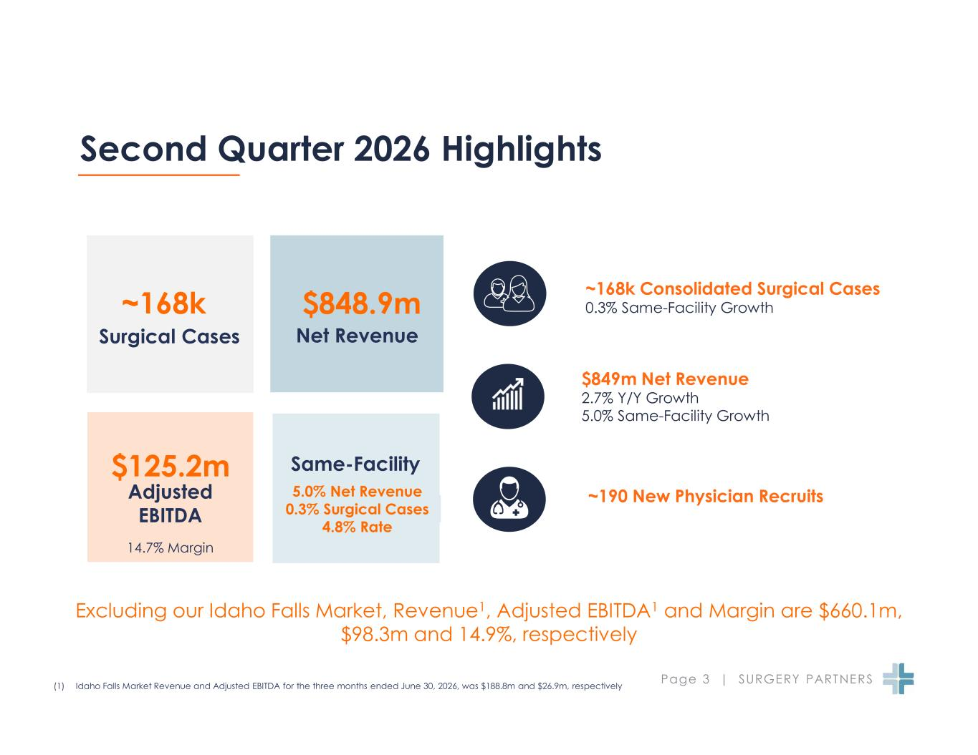
Page 3 | SURGERY PARTNERS Second Quarter 2026 Highlights ~168k Consolidated Surgical Cases 0.3% Same-Facility Growth $849m Net Revenue 2.7% Y/Y Growth 5.0% Same-Facility Growth ~190 New Physician Recruits Same-Facility 5.0% Net Revenue 0.3% Surgical Cases 4.8% Rate (1) Idaho Falls Market Revenue and Adjusted EBITDA for the three months ended June 30, 2026, was $188.8m and $26.9m, respectively Surgical Cases ~168k Net Revenue $848.9m Adjusted EBITDA $125.2m 14.7% Margin Excluding our Idaho Falls Market, Revenue1, Adjusted EBITDA1 and Margin are $660.1m, $98.3m and 14.9%, respectively

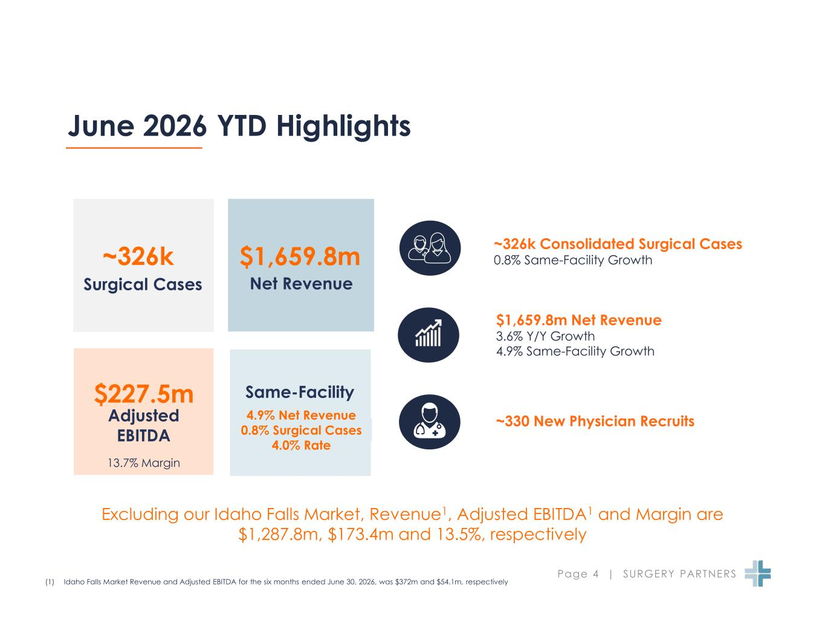
Page 4 | SURGERY PARTNERS June 2026 YTD Highlights ~326k Consolidated Surgical Cases 0.8% Same-Facility Growth $1,659.8m Net Revenue 3.6% Y/Y Growth 4.9% Same-Facility Growth ~330 New Physician Recruits Same-Facility 4.9% Net Revenue 0.8% Surgical Cases 4.0% Rate (1) Idaho Falls Market Revenue and Adjusted EBITDA for the six months ended June 30, 2026, was $372m and $54.1m, respectively Surgical Cases ~326k Net Revenue $1,659.8m Adjusted EBITDA $227.5m 13.7% Margin Excluding our Idaho Falls Market, Revenue1, Adjusted EBITDA1 and Margin are $1,287.8m, $173.4m and 13.5%, respectively

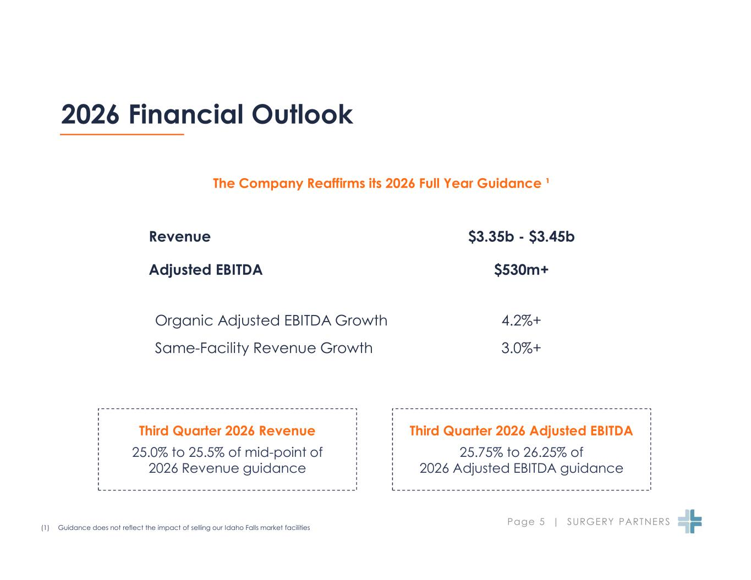
Page 5 | SURGERY PARTNERS 2026 Financial Outlook Third Quarter 2026 Adjusted EBITDA 25.75% to 26.25% of 2026 Adjusted EBITDA guidance Third Quarter 2026 Revenue 25.0% to 25.5% of mid-point of 2026 Revenue guidance The Company Reaffirms its 2026 Full Year Guidance ¹ (1) Guidance does not reflect the impact of selling our Idaho Falls market facilities Revenue $3.35b - $3.45b Adjusted EBITDA $530m+ Organic Adjusted EBITDA Growth 4.2%+ Same-Facility Revenue Growth 3.0%+

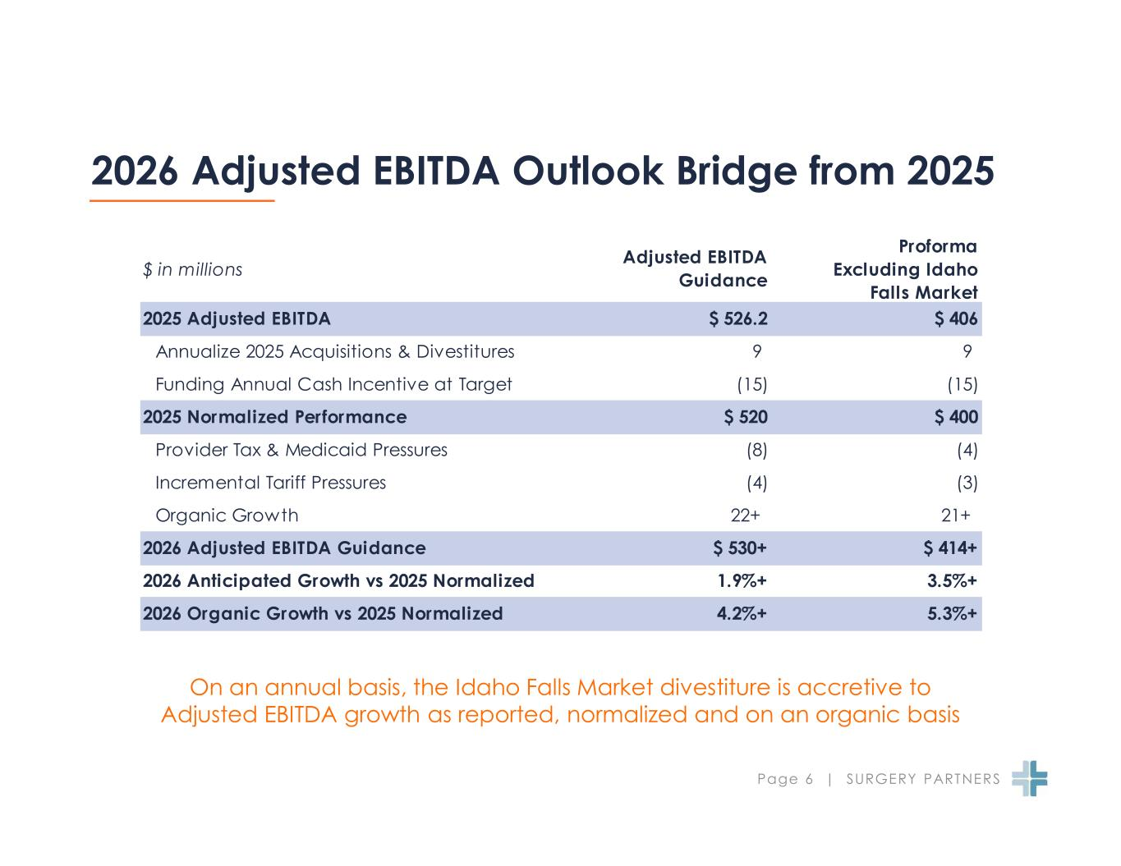
Page 6 | SURGERY PARTNERS 2026 Adjusted EBITDA Outlook Bridge from 2025 On an annual basis, the Idaho Falls Market divestiture is accretive to Adjusted EBITDA growth as reported, normalized and on an organic basis $ in millions Adjusted EBITDA Guidance Proforma Excluding Idaho Falls Market 2025 Adjusted EBITDA $ 526.2 $ 406 Annualize 2025 Acquisitions & Divestitures 9 9 Funding Annual Cash Incentive at Target (15) (15) 2025 Normalized Performance $ 520 $ 400 Provider Tax & Medicaid Pressures (8) (4) Incremental Tariff Pressures (4) (3) Organic Growth 22+ 21+ 2026 Adjusted EBITDA Guidance $ 530+ $ 414+ 2026 Anticipated Growth vs 2025 Normalized 1.9%+ 3.5%+ 2026 Organic Growth vs 2025 Normalized 4.2%+ 5.3%+

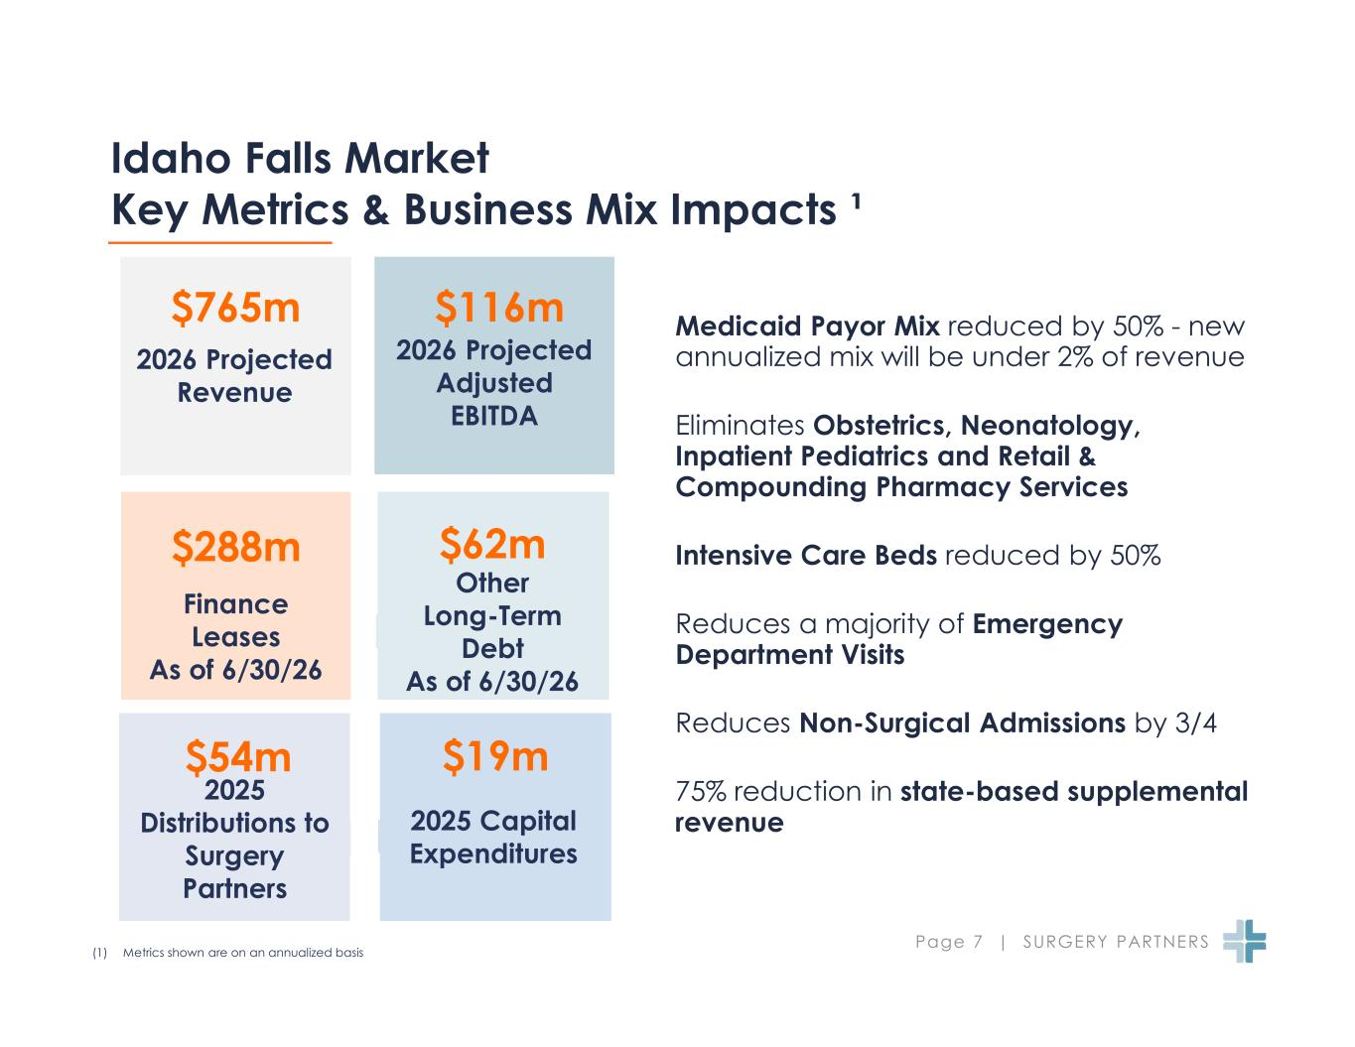
Page 7 | SURGERY PARTNERS Idaho Falls Market Key Metrics & Business Mix Impacts ¹ (1) Metrics shown are on an annualized basis Medicaid Payor Mix reduced by 50% - new annualized mix will be under 2% of revenue Eliminates Obstetrics, Neonatology, Inpatient Pediatrics and Retail & Compounding Pharmacy Services Intensive Care Beds reduced by 50% Reduces a majority of Emergency Department Visits Reduces Non-Surgical Admissions by 3/4 75% reduction in state-based supplemental revenue 2026 Projected Revenue $765m 2026 Projected Adjusted EBITDA $116m Finance Leases As of 6/30/26 $288m $62m Other Long-Term Debt As of 6/30/26 $54m $19m 2025 Capital Expenditures 2025 Distributions to Surgery Partners

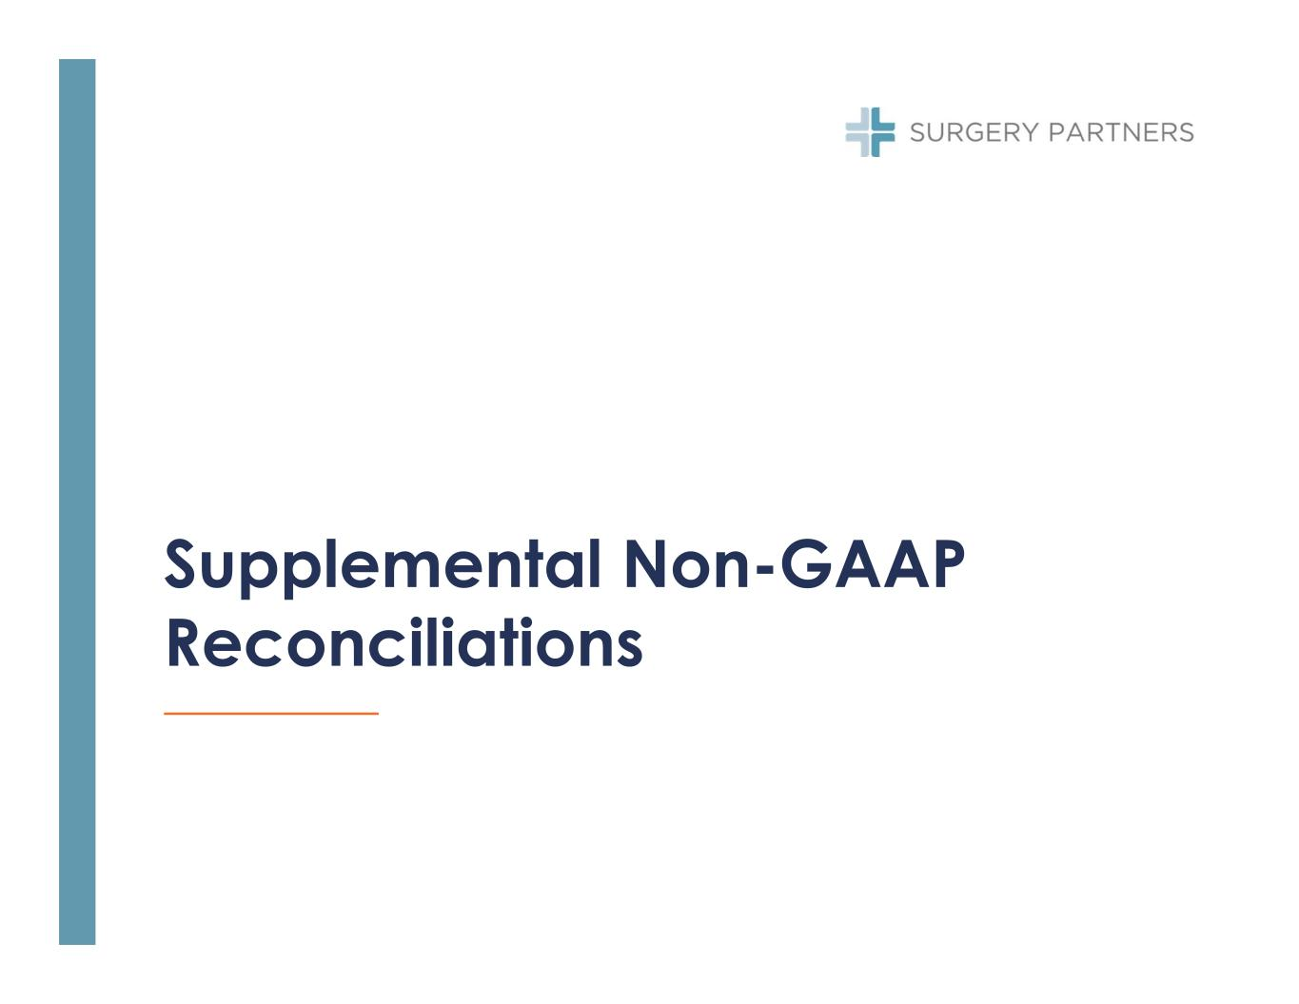
Supplemental Non-GAAP Reconciliations

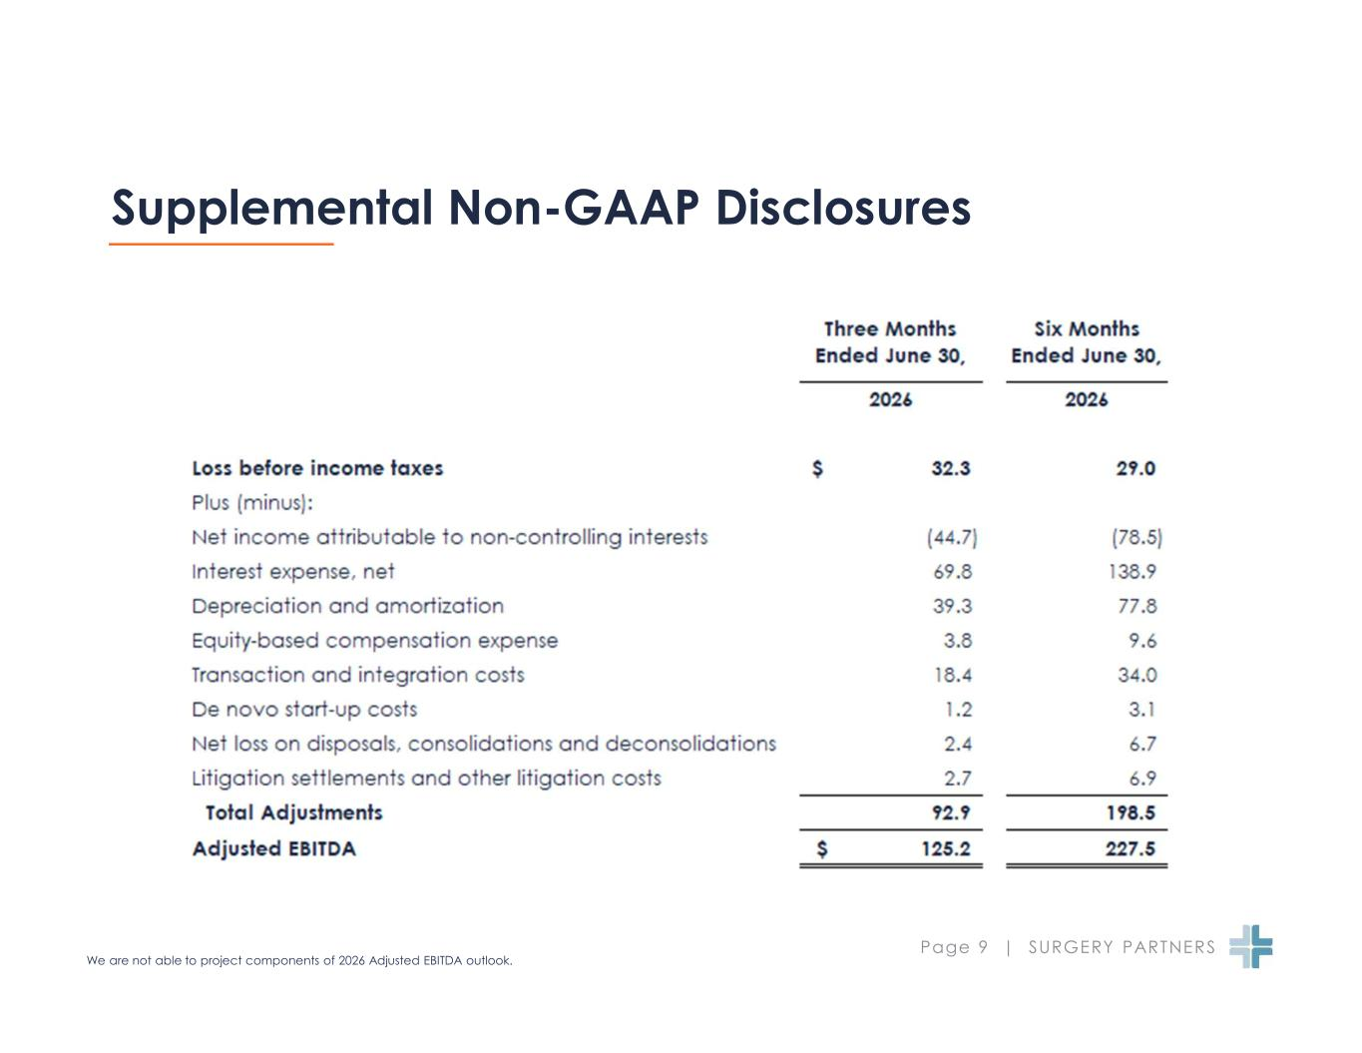
Page 9 | SURGERY PARTNERS Supplemental Non-GAAP Disclosures We are not able to project components of 2026 Adjusted EBITDA outlook.

